Covenant Presbyterian Church
Of
Fort Myers
DSpace Repository Users Guide
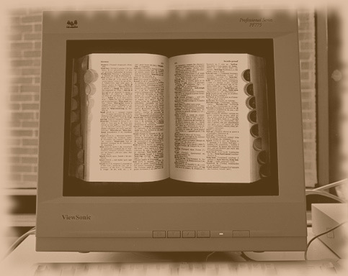
Developed by
Lesley L. Peterson
CyberStreet, Inc.
(239) 334-4484
lpeterson@cyberstreet.com
Table of Contents
Overview 1
Some important concepts and terminology 1
Communities and Collections 1
People and Groups 2
Items, Bitstreams and Bundles 2
Authorizations 2
Logging In 4
Site Navigation 6
The Side Menu 6
The Breadcrumb Trail 7
The Community List 8
Finding Items 9
Search DSpace 9
Browse 10
Adding and Maintaining Items 14
Adding Items to the Repository 14
Maintaining Items in the Repository 19
Item Status 20
Edit Item’s Authorization Policies 21
Withdraw Item From The Repository 21
Move Item To Another Collection 21
Completely Expunge Item 22
Item Bitstreams 22
Add a File to the Item 22
Item Metadata 24
Adding New Metadata 25
Editing Metadata 25
Logging Out 27
DSpace Resources 28

Overview
This digital repository has been developed for the purpose of preserving both the legacy and ongoing history of the Covenant Presbyterian Church of Fort Myers. It is built upon DSpace, which is a digital service that collects, preserves, indexes and distributes digital material. Repositories are important tools for preserving an organization's legacy; they facilitate digital preservation.
- DSpace is an open source software platform that enables organizations to:
- capture and describe digital material
- distribute an organization's digital items over the web through a search and retrieval system
- preserve digital items over the long term

This guide will provide step by step instructions for:
- Logging into the DSpace repository
- Navigating through the website
- Locating items that are stored within the repository
- Depositing new items into the repository
- Maintaining items that have been deposited previously
- Logging out

Some important concepts and terminology
DSpace uses several key concepts and terms with which a user should become familiar. A brief description follows:

Communities and Collections
The structure of a DSpace repository is based upon communities, each of which houses its own collection of items. A community may be thought of as a “category,” and a collection may be thought of as the items that are stored within that category. Communities may be further subdivided into sub-communities. Additionally, access to communities and collections may be restricted to certain people or groups.

People and Groups
Although many of DSpace's functions such as item searching and retrieval can performed anonymously, some features (and perhaps some items) are only available to certain "privileged" users. People and Groups are the way DSpace identifies users for the purpose of granting access privileges.
A Person is an individual user. Information that Dspace stores about a person includes:
- E-mail address
- First and last names
- Whether the user is able to log in to the system via the Web UI (User Interface)
- A password (encrypted), if appropriate
A group is an explicit list of People; anyone identified as one of those People also gains the privileges granted to the group. An example of a group might be Church Members; another example might be the Finance Committee. In this example, members assigned to the Finance Committee group would be able to view all of the items as the Church Members group, but the reverse might not necessarily be true. In this way, certain items are available only to People who have the appropriate authorization. Please note, a Person may be assigned to more than one Group.

Items, Bitstreams and Bundles
Each collection is composed of items, which are the basic archival elements of the archive. Each item is owned by one collection. Additionally, an item may appear in additional collections; however every item has one and only one owning collection.
Items are further subdivided into named bundles of bitstreams. Bitstreams are, as the name suggests, streams of bits, usually ordinary computer files -- .pdf files, MS Word documents, photos stored as .jpg image files, etc. Bitstreams that are somehow closely related, for example all of the .jpg files that are grouped into a single photo album, may be organized into bundles.

Authorizations
DSpace's authorization system is based on associating actions with objects and the lists of People who can perform them. These associations are called Resource Policies.
There are two special groups: 'Administrators', who can do anything in a site, and 'Anonymous', which is a list that contains all users. Assigning a policy for an action on an object to anonymous means giving everyone permission to do that action. (For example, most objects in DSpace sites have a policy of 'anonymous' READ.) Permissions must be explicit - lack of an explicit permission results in the default policy of 'deny'.
Collections, Communities and Items are discoverable in the browse and search systems regardless of READ authorization; however, this does not necessarily mean that an individual has the permission to read the bitstreams (ie, the files) contained therein.

Logging In
To log into the system, type the following into the address bar of your web browser: http://covpcfm.cyberstreet.com:8080/xmlui
You will be presented with the following screen:

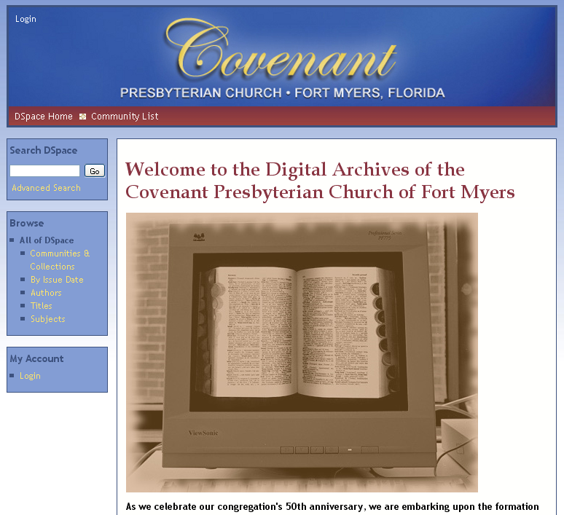

In the upper left hand corner of the screen, as well as in the left-hand sidebox labeled “My Account,” you will see a link labeled “Login.” Click on either of those two links; it doesn’t matter which.
You will then be taken to the Login screen, shown below:

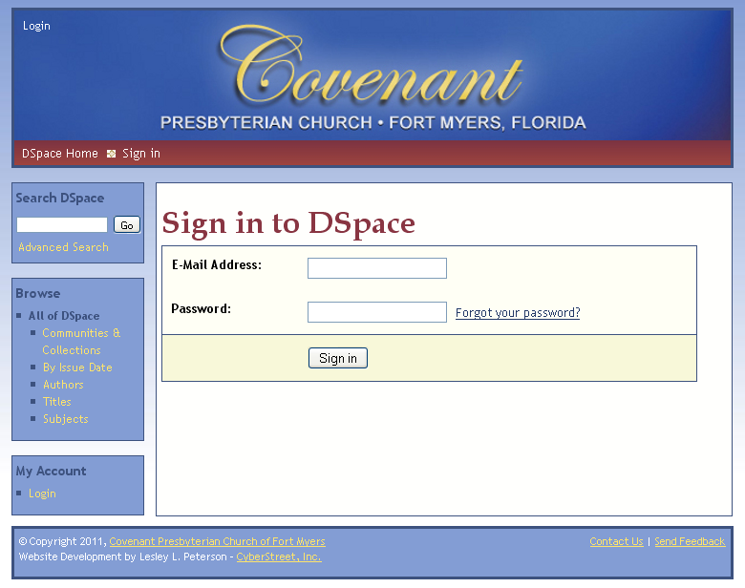

Enter your email address followed by your password, then click on the <Sign in> button. If you have forgotten your password, click on the “Forgot your password?” link; you will be prompted for your email address so that instructions for resetting your password may be sent to you.

Site Navigation

The Side Menu
The Side Menu presents you with a list of choices for interacting with the repository. The choices listed are dependant upon your level of administrative access.
Please note: If you have the required administrative access – either as a Person or as a member of an applicable group – you will see additional choices as you browse the Communities and Collections.

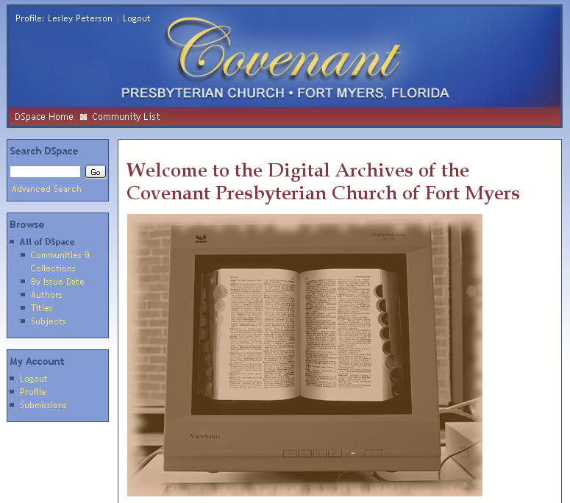

From the DSpace Home page, the Side Menu will be present you with the following list of options:
- Search DSpace
- Browse
  - All of DSpace (ie: the entire repository)
  - Communities and Collections
  - By Issue Date
  - Authors
  - Titles
  - Subjects
- My Account
  - Logout
  - Profile
  - Submissions

The Breadcrumb Trail
As you move through the repository, DSpace not only shows you where you can go, it also shows you where you have been. This is done by providing a breadcrumb trail immediately below the site’s masthead. Let’s take a look at the example below:

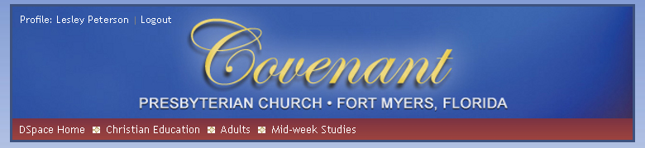

In this particular case, the user has navigated through the Christian Education community, through the Adults sub-community, and is viewing items that are stored under Mid-week Studies. If the user wishes to return directly to the top of the Christian Education community, he or she may do so by clicking on the “Christian Education” link displayed in the breadcrumb trail.

The Community List
Another way to navigate through the repository is to display the Community List. To do so, click on the “Communities and Collections” link in box labeled “Browse” in the Side Menu. You will then be presented with a branched-tree style list of the repository’s structure:

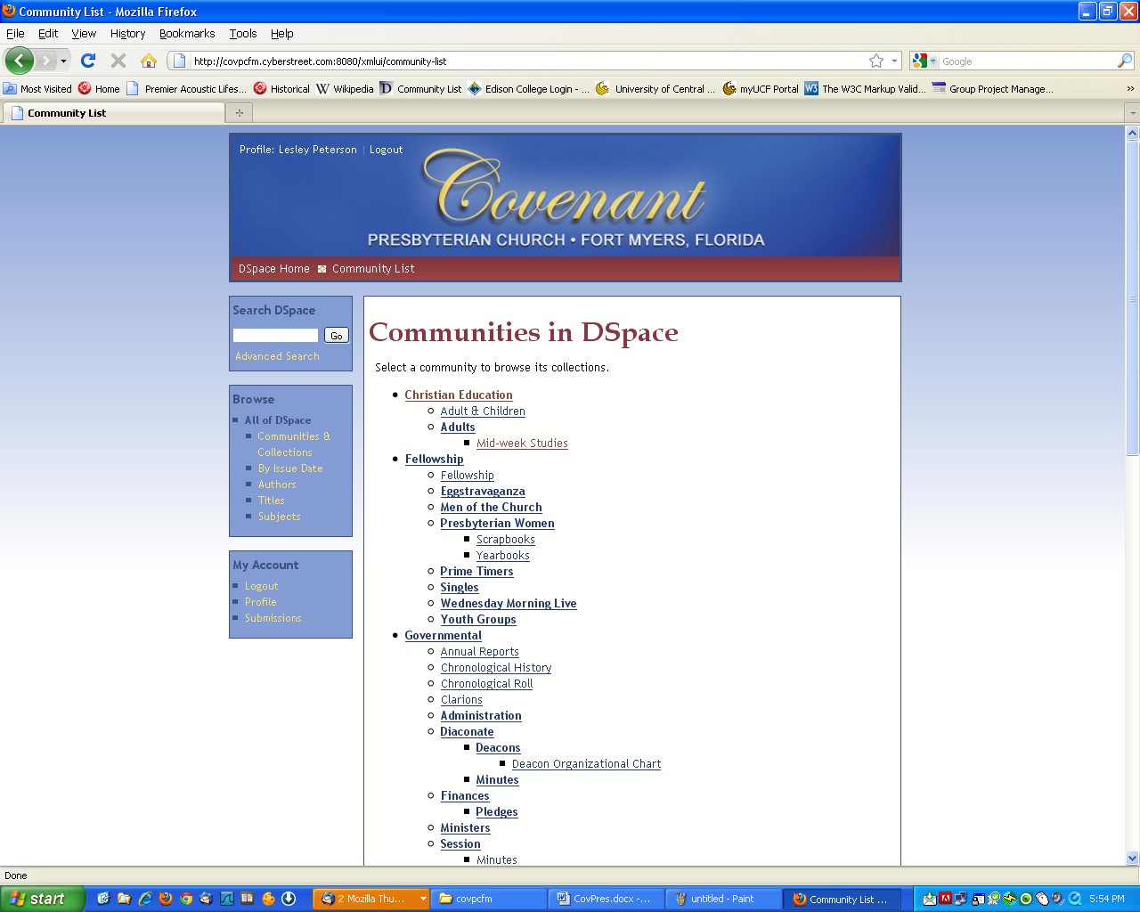

Finding Items
Finding items in the repository may be done in one of two ways: searching and browsing. Searching involves typing in key words or phrases, whereas browsing involves selectively navigating through the site.

Search DSpace
The simplest way to search DSpace is to type your search criteria – key words – into the Side Menu box labeled “Search DSpace” and then clicking on the button labeled “Go”:
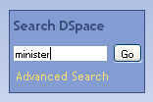
DSpace will search the repository for any items that have been designated as being associated with those key words, or – in the case of a searchable document – contains any of the words that you have entered. The results are then displayed:

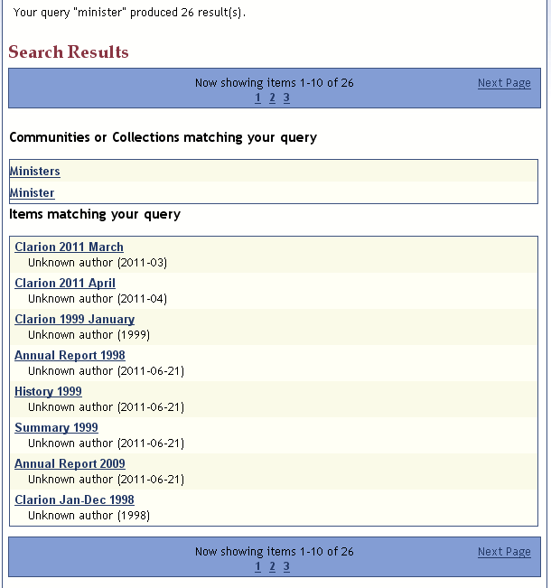
Of course, this can result in more matches than desired, especially in the case of searching with common words. So, another way of searching involves the “Advanced Search” link.

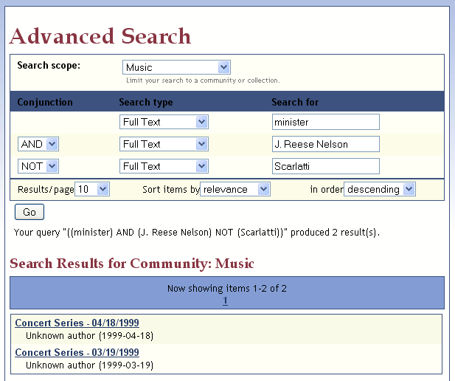

Now, you can narrow down your search criteria. You may search All of DSpace, or narrow your choices down to a particular community or collection. You may also specify that the search must contain more than one particular word or phrase, or it may exclude a particular word or phrase. This flexibility ensures that you are able to filter your searches and retrieve only the results that you are genuinely looking for.

Browse
Another means of locating items is through the Browse function, located in the Side Menu. You may browse by any of the following:
- Communities and Collections
- By Issue Date
- Author
- Titles
- Subject
As mentioned in the Site Navigation section of this manual, browsing by Collections and Communities will display a tree-style list of the entire repository. You may continue to click on links further down the tree structure until you find what items you are looking for.
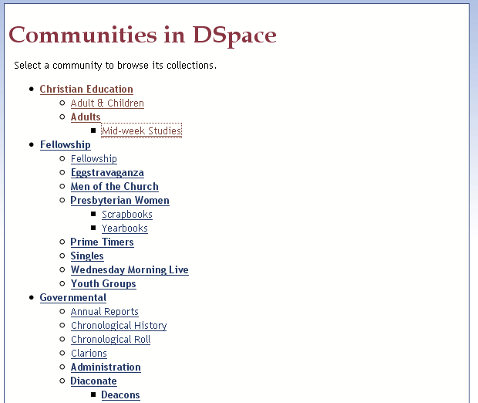

For example, we may start by clicking on “Christian Education.” From there, we see that there is a collection entitled “Adult & Children.” We may click to view that collection, or we may decide to go down even further into the sub-community labeled “Adults.”

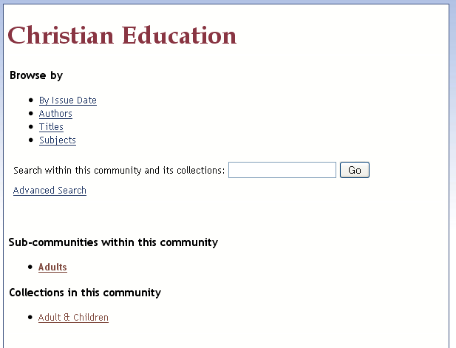

Let’s assume that we decide to view the “Adult & Children” collection in this community. We click on the link, and are then able to browse the items in this community by:
- Issue Date
- Author
- Titles
- Subjects
We decide to browse by Title, and see that there is currently just one item has been submitted:

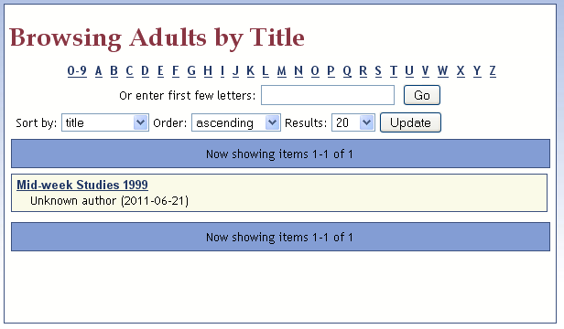

We click on the item and are then given the option to view it:
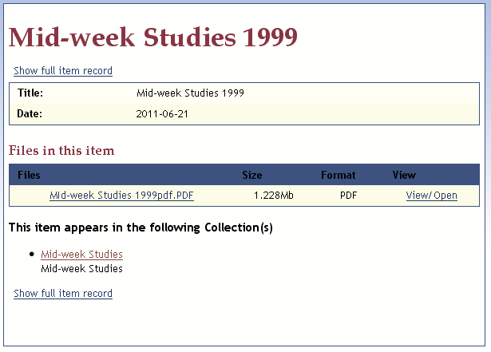

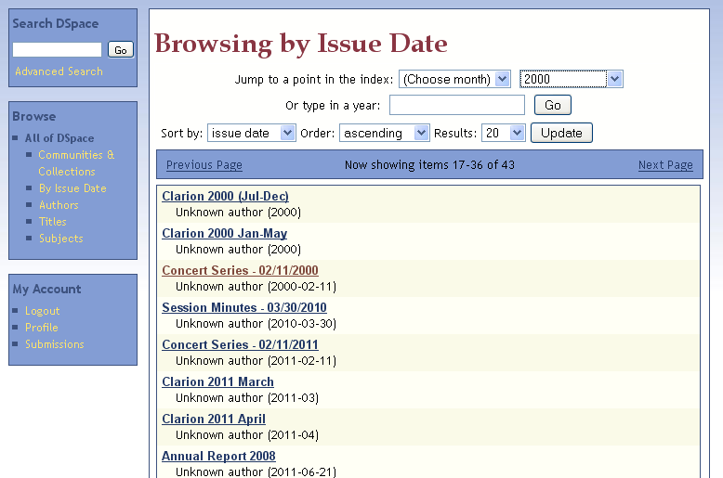

Adding and Maintaining Items
To add or maintain an item, you must be logged in as a Person or as a member of a Group that has Administrative privileges. If you do not have these privileges, speak with the Dspace Administrator to see if you may have these granted to you.

Adding Items to the Repository
Locate the collection in which you would like to place the item. You may do this by browsing the repository structure as described in the “Browse” topic of this manual.
In our example below, we will add an item to the Sunday Services – Bulletins collection. Click on the link labeled “Submit a new item to this collection.”
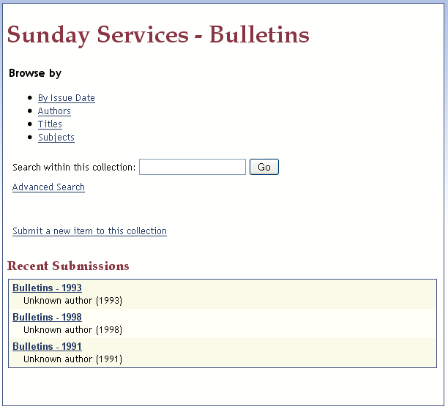

The first step in the Item Submission process requires you to describe the item. Enter in the relevant information, and then click on the button labeled “Next.”
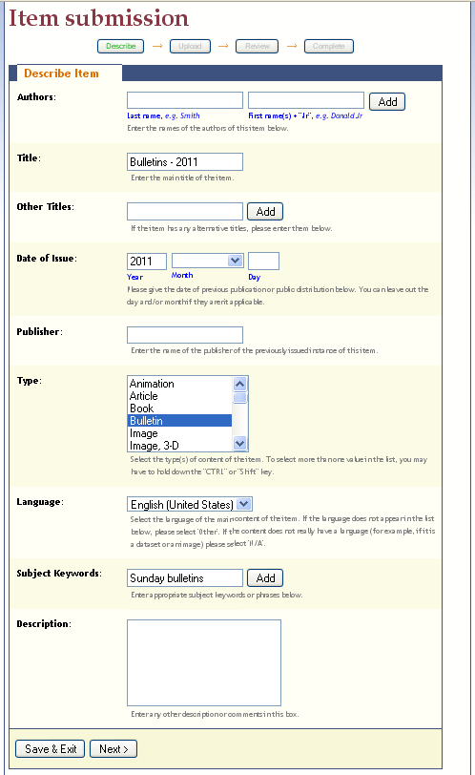

Next, you will be asked to upload the file(s) associated with this item. Since this item contains multiple Sunday Bulletins for 2011, we will be including several files. To select, we click on the <Browse> button and select from the files on our hard drive. To complete the upload, click on the button labeled <Upload file & add another> (do this even if you are only uploading a one file and are NOT adding another – this is necessary to complete the upload process). If you have uploaded the wrong file by mistake, simply click on the checkbox next to the file name and click the button labeled “Remove selected files.” Once you have finished uploading all of the desired files, click on the button labeled “Next.”
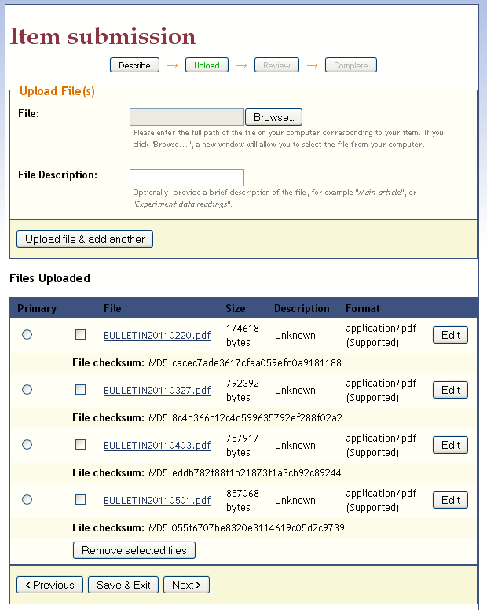

Finally, you will be given a chance to review the item. You may make any corrections need at this point. When you are satisfied, click on the button labeled “Complete submission” to complete the process.
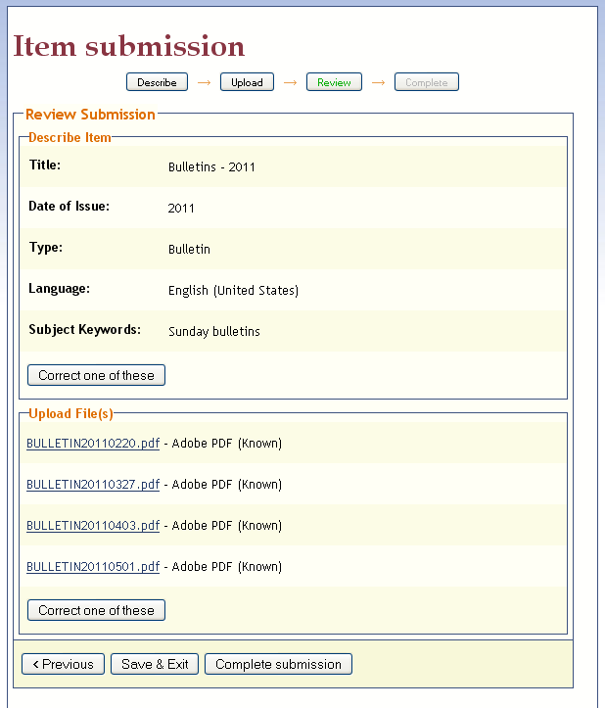

Dspace will confirm that the item has been submitted successfully. If you have another item to submit, you may click on the button labeled “Submit another item.”

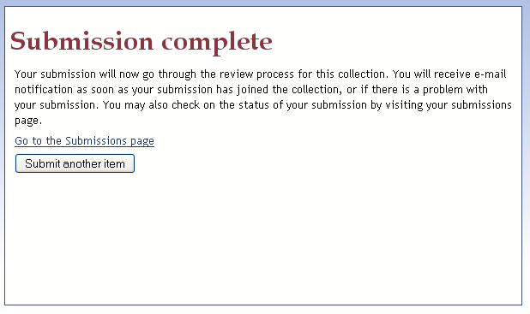

Please note: If at any time you cannot complete a submission, you may click on the button labeled “Save and exit.” This will save you work, but it will not be added into the repository until you come back and complete the submission process. You may do this at any time by going to the Submissions page; the link to do so is found in the Profile box located in the Side Menu.

IMPORTANT: You site’s indexing function has been set up to automatically update every night. Items placed in the repository will be found via the search function the day after they have been added.

Maintaining Items in the Repository
There may be times when you wish to go back and make changes to an item in the repository. This may be due to a number of reasons including:
- correcting typographical errors to the item’s title, subject, or other descriptor
- correcting an error made in entering the items date
- adding an additional file to the item or removing a file that was added in error
- changing the item’s category by moving it from one collection to another
- withdrawing an item from public view
- removing erroneous duplications
To make any such changes to an item, first search or browse the repository to find the desired item. When you have found the item, click on the link labeled “Edit this item” in the Context box located in the Side Menu.
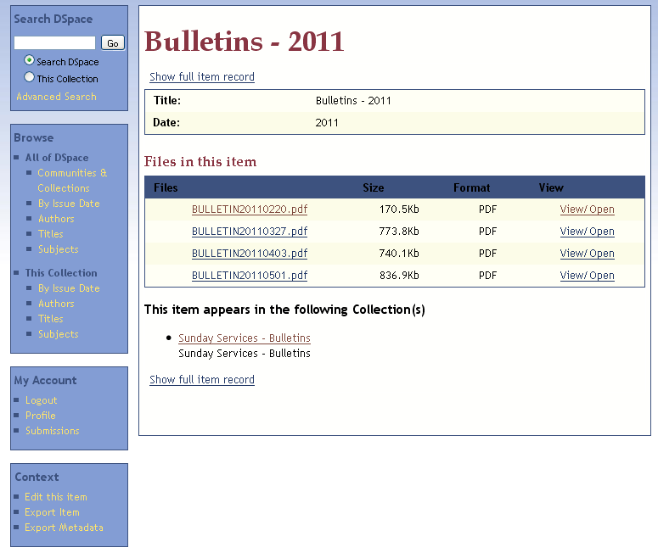
You will be presented with the item, along with a tabbed menu:
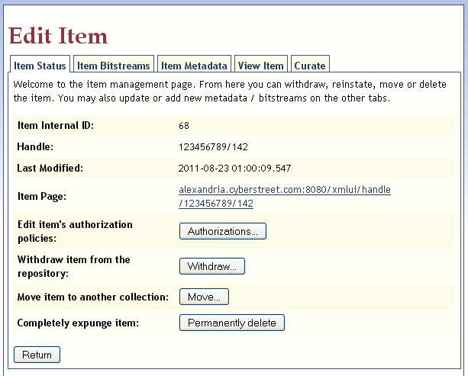

For the purposes of this manual, we will be concerning ourselves with the following tabs: Item Status, Item Bitstreams, Item Metadata.

Item Status
This tab relates to the status of the item within the archive. From here, you may:
- Change the level of authorization access of the item
- Withdraw the item from the search and browse indices
- Move the item to another collection (re-categorize the item)
- Remove it from the repository completely

Edit Item’s Authorization Policies
All items inherit the authorization policies of the communities and collections to which they belong. Changing these is outside the scope of this manual. Contact the repository’s Administrator to perform this task.

Withdraw Item From The Repository
As discussed, this function withdraws the item from the browse and search indices, thereby rendering it invisible.
To withdraw an item, click on the “Withdraw” button. You will then be taken to a screen which displays the full item record and will ask you to confirm the withdrawal request. Click on the “Withdraw” button to confirm the request, or click on the “Cancel” button to cancel the request.

Move Item To Another Collection
To move the item to another collection (re-categorize the item), click on the button labeled “Move.” You will be presented with the following screen:

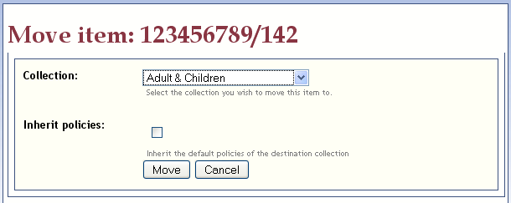

Select the collection (category) to which you would like to move the item. Click on the “Inherit policies” checkbox, thus ensuring that this item receives the authorization policies of the collection in which it is being placed.
To cancel the request to move the item, simply click on the button labeled “Cancel.”

Completely Expunge Item
This option removes the item from the repository completely and permanently. This should be used only if an item has been accidentally added to the archive more than once, resulting in a duplicate entry.
To expunge an item, click on the “Permanently delete” button. You will then be taken to a screen which displays the full item record and will ask you to confirm the deletion request. Click on the “Delete” button to confirm the request, or click on the “Cancel” button to cancel the request.

Item Bitstreams
This function allows you to add or remove individual files from the item. You will be shown a list of all of the files that are contained within this item. The files that you have uploaded with be grouped together under the heading “Bundle: Original.” If you have uploaded searchable files such as .PDFs, the system will automatically generate corresponding files containing the extracted text. This will happen during the nightly indexing task that is scheduled to take place automatically. These will be grouped together under the heading “Bundle: Text.”
The system will also display the native format of each file (PDF, Word, etc.) and will allow you to click on a link to view the file, if desired.

Add a File to the Item
To add an additional file to the item, click on the link labeled “Upload a new bitstream.”
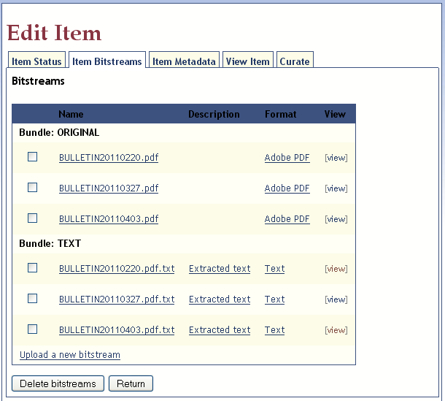
You will be asked which type of “Bundle” you are uploading. Accept the Content Files (default) type.
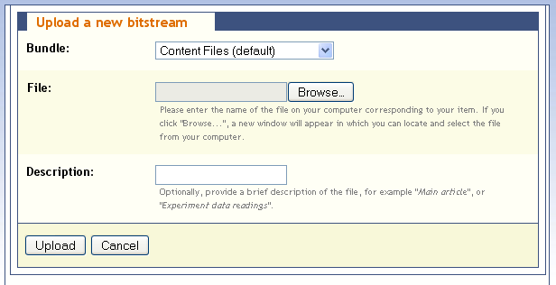

To select, we click on the <Browse> button and select from the file on our hard drive. Click on the button labeled <Upload> to complete the addition request, or click on the button labeled <Cancel> to cancel the addition request.
You will be returned to the Item Bitstreams tab of the Edit Item screen. Please note that the TEXT bundle has not yet been created for the newly uploaded file. Once again, it will generate and be added automatically during the scheduled nightly reindexing.

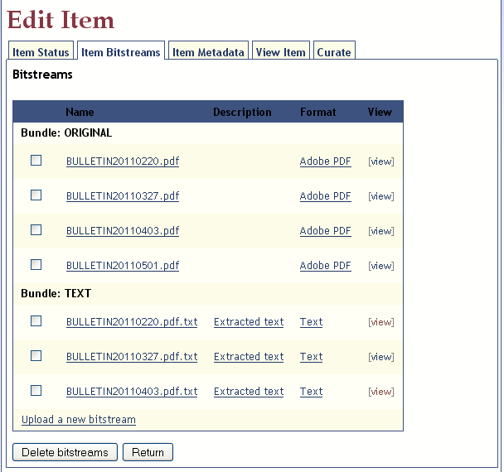

Item Metadata
An item’s descriptive information is referred to as its metadata. This function allows you to edit any of the item’s metadata.
DSpace provides the means to allow for a wealth of item metadata, more than what is necessary and applicable to this particular repository. Therefore, the user provided metadata has been pared down to only that which is essential and useful. The user should edit ONLY the following:
Label displayed on Item Submission Screen: | Corresponding metadata name:
Author | dc.contributor.author
Title | dc.title
Other Titles | dc.title.alternative
Date of Issue | dc.date.issued
Publisher | dc.publisher
Type | dc.type
Language  - English (United States) - en_US  - English- en  - Spanish- es  - German- de  - French – fr  - Italian – it  - Japanese – ja  - Chinese – zh  - Other - other | dc. language. Iso
Subject Keywords | dc. subject
Description | dc.description

Adding New Metadata
To add a new piece of metadata, consult the above chart and then select the appropriate metadata label from the dropdown list. Then enter in the appropriate value. In the example below, the metadata name for the item Description is dc.description, and the value is a description that the user types into the text box. To complete the addition, click on the button labeled <Add new metadata>.

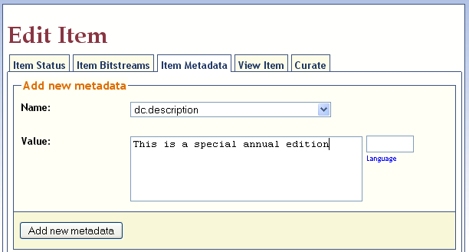

Editing Metadata
There may be times when you wish to change certain pieces of metadata. For example, you may have entered the wrong date issued for the item. The Edit Item tab displays all of the metadata that is currently associated with the item. You may change any of these by entering the corrected values into the associated textboxes. Please refer to the above chart so as to identify the correct metadata name.
Important! – DSpace automatically logs who submitted an item into the repository, when it was submitted, and when any changes have been submitted. It stores this with the metadata name dc.description.provenance. For the sake of system integrity, DO NOT change the values associated with these pieces of metadata. Also, the metadata named dc.identifier.uri is an internal identifier used by the system; DO NOT change this value. The only values that should be changed are the ones identified in the table above.
The next page displays the metadata edit section of the Item Metadata tab:
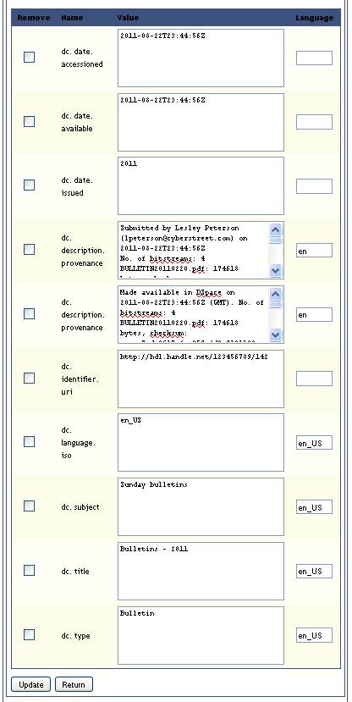

Logging Out
It is very important to remember to log out when you have finished visiting the repository. This prevents another person from gaining access to the system with your user credentials.
Logging out is very easy. Simply click on the link labeled “Logout” located either at:

The top left corner of the website header:

Or, in the “My Account” box in the Side Menu.
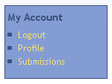

DSpace Resources
This guide has presented basic information for interacting with the DSpace repository. There are other resources that are available online, each of which contain a wealth of detailed technical information. A sampling of them is provided below.
- DSpace Homepage – http://www.dspace.org
- DSpace Wiki – http://wiki.dspace.org/
- DSpace Documentation – https://wiki.duraspace.org/display/DSDOC/DSpace+Documentation
- DSpace Technical FAQ - http://wiki.dspace.org/TechnicalFaq
- DSpace Resources Listing (including System Documentation and Mailing Lists) -http://wiki.dspace.org/DspaceResources

